

Risk Stratification of Vehicle Complaints:
Classifying Risks for Proactive Measures

Table Of Contents

Table Of Contents 1
Table of Figures 2
List of Tables 3
- Introduction 6
  - Background 6
  - Current Scenario of Vehicle Recalls and Safety Delays 7
  - Impact of Recalls on Consumer Trust and Sales 8
  - Problem Statement 8
  - Research Questions 8
- Literature Review 9
- Data Preparation and Overview 13
  - Introduction 13
  - Dataset Description 14
    - Consumer Complaints Dataset 14
    - Defect Investigations Dataset 15
    - Recall Dataset 16
  - Target Variable 17
  - Exploratory Data Analysis 20
  - Data Preprocessing and Transformation 27
    - Handling Missing Values 27
    - Data Imputation 28
    - Feature Engineering 29
    - Data Aggregation 32
  - Assumption Tests 33
    - Normality 33
    - Homoscedasticity 35
    - Multicollinearity 36
    - Independence of Observations 36
    - Correlation Matrix for Linearity 37
- Data Modelling 38
  - NLP-Based Neural Network Analysis of Complaint Descriptions 41
    - Data Preprocessing and Text Cleaning 42
    - Sentence Embedding Using SBERT 42
    - Data Merging and Cleaning Steps 43
    - Deep Learning Model Architecture 43
    - Deep learning Model Training and Performance 45
    - Data Preparation for Model Building 45
  - Understanding XGBoost 46
    - Hyperparameter Tuning with Random Search 47
  - XGBoost Model Variants and Evaluation 48
- Discussions 54
  - What key factors in historical recall and complaint data contribute to prioritizing high-risk complaints that might lead to recalls? 54
  - Impact of Vehicle Technological Advancements on Recalls 55
- Conclusion 57
Limitations and Future Directions 58
References 59

Table of Figures
Figure 1. Target Variable Distribution 19
Figure 2. Total Complaints by Region 20
Figure 4. Impact of Vehicle Age on Crash Frequency 21
Figure 5. Yearly Trends in Reported Crash Deaths and Injuries 22
Figure 6. Identifying the Automakers with the Most Complaints 23
Figure 7. Complaint Trends Over Time 24
Figure 8. Complaint Trends Over Time 25
Figure 9. Crash Trends Across States 25
Figure 10. Complaint Trends Regarding Vehicle Components 26
Figure 11. Box Plots for Normality of Variables 34
Figure 12. Levene’s Test Results 36
Figure 13. Feature correlation Heatmap 38
Figure 14. Proposed Risk Classification Workflow with Multiple Model Architecture 40
Figure 15. Confusion Matrix 52
Figure 16. Top 20 Features 53
Figure 17. Recall distribution over the years 55
Figure 18. Comparison of mechanical and software defects trend 55

List of Tables
Table 1. Consumer Complaints Metadata 11
Table 2. Defect Investigations Metadata 12
Table 3. Recall Metadata 13
Table 4. Detailed Architecture and Training Configuration… 43
Table 5. Parameter grid for grid search 47
Table 6. Optimal hyperparameter identified after 60 trials 47
Table 7. Model Outputs 48
Table 8. Final Model summary 50

Acknowledgments

We would like to express our sincere gratitude to Dr. Sameh Shamroukh for his invaluable mentorship and continuous guidance throughout the duration of our research. His insights and support during the Business Process Analytics course played a pivotal role in shaping our understanding and execution of the project.
Our heartfelt thanks also go to God Almighty, whose blessings and grace provided us with the strength, clarity, and perseverance to carry out this work to completion.
We extend our appreciation to every member of Group 5 for their dedicated contributions and collaborative efforts toward the successful completion of our project, “Risk Stratification of Vehicle Complaints: Classifying Risks for Proactive Safety Management.”
We sincerely hope that this research meets its intended objectives and adds meaningful value to the field of Data Science, particularly in the application of machine learning for enhancing public safety and informing regulatory decision-making.

Abstract

This report presents a data-driven approach to identifying high-risk vehicle complaints that may lead to formal investigations or recalls. Using a combination of structured vehicle complaint data from the National Highway Traffic Safety Administration (NHTSA) and advanced Natural Language Processing (NLP) techniques, we developed a predictive model capable of classifying complaints by risk level. Sentence embeddings from complaint narratives were generated using transformer-based models and integrated with structured features to train multiple machine learning models, with XGBoost emerging as the best-performing algorithm. The model achieved strong accuracy and macro F1 scores, particularly after addressing class imbalance using SMOTE and undersampling techniques. Additionally, this study explores the impact of technological advancements — such as electric vehicles (EVs), advanced driver assistance systems (ADAS), and over-the-air software updates — on recall patterns, highlighting a significant shift from mechanical to software-related defects. The findings provide practical insights for regulators and manufacturers to enhance early risk detection, prioritize safety investigations, and adapt to the evolving landscape of vehicle safety.

Keywords

Vehicle complaints, NHTSA, predictive modeling, vehicle recalls, natural language processing, XGBoost, SMOTE, automotive safety, machine learning, complaint classification, ADAS, EV, software recalls, risk prediction.

Introduction

Background

The United States has one of the most dominant automotive markets globally, with vehicle ownership playing a fundamental role in daily life. As of 2022, approximately 91.7% of U.S. households owned at least one vehicle, and 22.1% of households owned three or more vehicles (Forbes, 2023). This high car ownership rate underscores the industry's critical importance, not just for mobility but also for economic stability and infrastructure planning. With millions of vehicles on the road, ensuring their safety is paramount, making vehicle recall a crucial issue for consumers, manufacturers, and regulators alike.
Some automakers have built strong consumer trust through consistent reliability, innovation, and responsive customer service. According to Consumer Reports, brands such as Lexus, Toyota, and BMW consistently rank among the highest in owner satisfaction, with over 70% of their customers expressing willingness to repurchase (Consumer Reports, 2024). This trust is often maintained through rigorous quality control measures, quick responses to defects, and transparent recall management.
However, recalls and safety investigations have a direct impact on consumer perception. Poorly handled recalls can erode confidence in a brand, causing long-term damage to its reputation and sales. In contrast, companies that proactively address recalls and maintain transparency tend to mitigate consumer backlash (Business Insider, 2024). For instance, despite historical concerns over

reliability, brands like Tesla and Rivian have maintained strong customer loyalty due to their innovation-driven brand positioning and direct consumer engagement (Business Insider, 2024).
Understanding the relationship between vehicle ownership, manufacturer trust, and recall management is essential for automakers, policymakers, and researchers. This study seeks to analyze how predictive analytics and machine learning can be leveraged to detect early warning signs of vehicle defects before they escalate into large-scale recalls.

Current Scenario of Vehicle Recalls and Safety Delays

The scale and frequency of vehicle recalls have increased significantly in recent years, driven by mechanical failures, software glitches, and electronic malfunctions. In 2023 alone, there were over 1,000 recall campaigns in the United States, affecting millions of vehicles (NHTSA, 2024). Some of the most notable recalls include:
General Motors (GM) Recall (2024): Over 90,000 Cadillac and Chevrolet vehicles were recalled due to transmission issues that could cause sudden front-wheel lock-up, increasing accident risk (New York Post, 2024).
Ford Kuga Hybrid Recall (2023): Thousands of Ford Kuga plug-in hybrid vehicles were recalled due to battery malfunctions, which posed fire hazards (The Sun, 2023).
Ineos Grenadier Recall (2024): Over 7,000 SUVs were recalled after reports of doors opening unexpectedly while driving due to defective latches (Financial Times, 2024).
Takata Airbag Recall (2014–2024): The largest recall in automotive history, affecting over 100 million vehicles worldwide. These faulty airbags have been linked to at least 28 fatalities in the

U.S. and 35 globally, with defects causing the inflators to explode upon deployment (NHTSA, 2024).
These recalls highlight the critical need for early detection and proactive recall management. The traditional method of identifying safety issues through consumer complaints and internal quality checks is no longer sufficient, given the growing complexity of modern vehicles.

Impact of Recalls on Consumer Trust and Sales

Recalls not only pose safety risks but also have severe financial and reputational consequences for automakers. Research shows that frequent recalls negatively affect consumer trust, leading to declining customer retention rates and decreased stock market performance (BBN Times, 2023). When recalls are mishandled or delayed, consumer confidence further erodes, impacting future sales and brand perception (Forbes, 2023). However, companies that handle recalls transparently and proactively can maintain consumer trust. A well-managed recall strategy can even strengthen brand loyalty by demonstrating accountability and commitment to customer safety (Forbes, 2023).

Problem Statement

Despite advancements in automotive technology, recall management remains reactive rather than proactive. Traditional manual review of consumer complaints and recall trends is inefficient, given the growing volume of vehicle defect reports. There is a pressing need for automated, data-driven solutions that can identify emerging safety issues before they escalate into major recalls.

Research Questions

This study aims to address the following research questions:

    - Predictive Analytics for Vehicle Recalls

      - What key factors in historical recall and complaint data contribute to prioritizing high-risk complaints that might lead to recalls?
    - Impact of Vehicle Technological Advancements on Recalls

      - How have vehicle recall trends evolved in the five years before and after major technological advancements (ADAS, EVs, self-driving features)?
      - Has the advancement of vehicle software (over-the-air updates, automated braking) shifted recall patterns from mechanical failures to software-related issues?
This research contributes to automotive safety and regulatory advancements by:

- Developing an ML-driven risk classification model for consumer complaints.

- Enhancing early warning systems for vehicle defects and predicting potential recalls.

- Providing insights into how technological advancements shape the nature of vehicle safety failures.

Literature Review

Like any other research, this one is specific to finding out how machine learning and natural language processing (NLP) can enhance vehicle recall forecasting and consumer complaint investigation. Our goal is to look at previous research in the area, including issues and constraints that might affect our study as well. At the core of our research is the development of a machine learning system that can categorize car complaints into risk levels and predict potential recalls. The filtering procedure/selection process, as facilitated by machine learning models and algorithms, remains our main interest.

Several research studies have examined several approaches to vehicle complaint analysis and recall prediction. Ghazizadeh et al. (2014) applied text mining techniques to analyze free-response consumer complaints in the NHTSA Vehicle Owner's Complaint Database. Their study aimed to identify clusters of vehicle-related issues and detect emerging safety concerns. Applying NLP techniques such as Latent Semantic Analysis (LSA) and Hierarchical Clustering, they mined complaint patterns and grouped complaints into clusters based on common issues like tire defects, airbag failures, and braking problems. Their trend analysis indicated spikes in complaints following massive recalls such as the Toyota unintended acceleration recall in 2009. This study was, however, constrained with no predictive analysis machine learning models, unstructured data integration, and media bias impacting complaint surges. Our research addresses these gaps by using ML models like XGBoost and Random Forest to classify predictive recall, blending structured recall and investigation data, and classifying complaints as high, medium, and low risk instead of clustering them.
Zhang et al. (2015) also studied user-uploaded content on car forums and forecasted recalls before official announcements by manufacturers. They removed defect-related words using Part-of-Speech Tagging and Frequent Pattern Mining and utilized Machine Learning Models such as Naïve Bayes, KNN, and Decision Trees to forecast the recall-related forum posts' classification. They learned that online posts contain early warnings for potential defects, but their model could only give a 50% accuracy score and therefore demonstrated the need for better ML models. Our research improves this by using real complaint data for NHTSA instead of just forums and using more advanced ML models such as BERT-based NLP to enhance recall prediction.
To predict future recall, Maniyur et al. (2017) merged recall records with social media complaints (forums, Twitter). Though social media data lacked organized recall integration, they

discovered that it was in agreement with recall trends. Furthermore, their model did not rank complaints based on their level of severity, indicating it did not function effectively when handling high-priority instances. In an effort to overcome this constraint, we employ risk-based prioritization to categorize complaints as high, medium, or low risk and integrate NHTSA complaints, investigations, and recalls into an integrative prediction framework.
Khodadadi et al. (2021) used CNN-BiLSTM, a deep learning technique, to process customer service complaints and assign departmental labels. Even though this study concentrated more on vehicle diagnostics than recall prediction, it is still relevant to comprehending how NLP and deep learning can be used to process and categorize vast amounts of text-based data pertaining to automotive problems. The model's 18% increase in classification accuracy demonstrates the effectiveness of deep learning in text-based analysis. Although it lacked rank-ordered safety threats and recall data, its methodology provides a basis for our study that uses natural language processing (NLP) to categorize structured complaints. This is expanded in our work by using BERT-based NLP for recall probability prediction and structured recall and investigation data for the more nuanced interpretation of consumer complaints.
Maione et al. (2023) used regression, classification, and clustering models to compare recall patterns in the US, Brazil, and the EU. Although they demonstrated that recalls have generally increased globally, their model lacked real-time monitoring and was unable to predict individual recalls with any degree of accuracy. We expand on their work by using real-time complaint analysis to identify new safety risks early on and by using Random Forest and XGBoost to maximize classification accuracy for risk classification.

With these studies, several research gaps remain like the absence of a unified complaint-recall model, limited machine learning approaches, no real-time complaint prioritization, and basic NLP methods. These issues are addressed by our study by integrating complaints, recalls, and investigations into a single prediction system through advanced ML models such as XGBoost, Random Forest, and BERT for NLP to improve recall prediction, classifying complaints as high, medium, and low risk to make quick responses, and through BERT-based NLP to improve text understanding and recall prediction.
These studies have laid the groundwork for ML in car recalls but do not incorporate real-time monitoring, structured recall integration, and advanced ML techniques. The studies presented here are based on these works and merge several datasets (studies, complaints, recalls) for enhanced predictions, employing state-of-the-art ML models (Random Forest, XGBoost, BERT) for enhanced classification and detection of recalls, and classifying complaints by risk levels (Low, Medium, High) to reduce delays in recalls. Through addressing these gaps, our research enhances vehicle safety tracking and recall handling to facilitate speedier, smarter, and more effective recall processing. Through AI, we are capable of making recall detection proactive instead of reactive and therefore prevent accidents from taking place.

Issues Faced by Previous Research and Their Implications

A number of these works also faced challenges in generalizability due to the constraints on their datasets. Khodadadi et al. (2021) began from fleet vehicle diagnostic reports, which places limitations upon the extrapolation of their findings to broader consumer markets. Similarly, previous research that utilized social media and forum-based data came with variability because not everyone uses those platforms to report defects. In this study, we negate such limitations by

utilizing only structured complaints and recall data from NHTSA, giving us a more uniform and standardized dataset.
These studies also encountered huge challenges in data integration, model accuracy, and feature extraction. The biggest challenge was the lack of structured recall data integration, as can be seen in Zhang et al. (2015) and Maniyur et al. (2017), which restricted their ability to make accurate recall predictions. Maione et al. (2023) also encountered challenges with real-time monitoring, which did not enable their model to predict recall risks. Another significant challenge was distinguishing between actual safety defects and low-severity consumer complaints, a limitation of Khodadadi et al. (2021). In our research, we address these challenges by integrating structured complaint, investigation, and recall data into a single predictive framework, using state-of-the-art NLP methods to enhance text analysis, and applying real-time trend detection to detect high-risk complaints more efficiently.

Data Preparation and Overview

Introduction

In this section, we describe the structure, characteristics, and key attributes of the datasets used in our analysis of vehicle recalls, complaints, and defect investigations. The datasets were obtained from the National Highway Traffic Safety Administration (NHTSA) and include Consumer Complaints, Defect Investigations, and Recall Records. These datasets provide valuable insights into vehicle safety defects, manufacturer recalls, and consumer-reported issues, forming the foundation for our research.

Dataset Description

The three datasets used in this study are as follows:

Consumer Complaints Dataset

The Consumer Complaints dataset contains 1,213,407 records and 49 columns, capturing safety-related defect complaints reported to NHTSA since January 1, 1995. The data set provides details on vehicle crashes, fires, injuries, and fatalities associated with consumer complaints. This dataset is crucial for analyzing patterns in consumer-reported complaints, identifying common vehicle defects, and assessing the severity of reported issues.

Table 1.
Complaints metadata
Field Name | Description
CMPLID | Unique sequence number for each complaint.
ODINO | Internal reference numbers may be repeated for multiple  components.
MFR_NAME | Name of the manufacturer.
MAKETXT | Make of the vehicle or equipment.
MODELTXT | Model of vehicles or equipment.
YEARTXT | Model year, 9999 if unknown or N/A.
CRASH | Indicates if the vehicle was involved in a crash ('Y' or 'N').
FAILDATE | Date of the reported incident (YYYYMMDD).
FIRE | Indicates if the vehicle was involved in a fire ('Y' or 'N').
INJURED | Number of people injured.
DEATHS | Number of fatalities.
COMPDESC | Description of the defective component.
CITY | Consumer's city of residence.
STATE | Consumer's state code.
VIN | Vehicle Identification Number (VIN).
DATEA | Date complaint was added to the file (YYYYMMDD).
LDATE | Date complaint received by NHTSA (YYYYMMDD).
MILES | Vehicle mileage at the time of failure.
OCCURRENCES | Number of occurrences of the complaint issue.
CDESCR | Full description of the complaint.

CMPL_TYPE | Source of complaint (e.g., Hotline, Web, Insurance).
POLICE_RPT_YN | Was the incident reported to the police? ('Y' or 'N').
PURCH_DT | Date of vehicle purchase (YYYYMMDD).
ORIG_OWNER_YN | Was the complainant the original owner? ('Y' or 'N').
ANTI_BRAKES_YN | Does the vehicle have anti-lock brakes? ('Y' or 'N').
CRUISE_CONT_YN | Does the vehicle have cruise control? ('Y' or 'N').
NUM_CYLS | Number of engine cylinders.
DRIVE_TRAIN | Drive train type (AWD, 4WD, FWD, RWD).
FUEL_SYS | Fuel system type (e.g., Fuel Injection, Turbo).
FUEL_TYPE | Fuel type (Gas, Diesel, Hybrid, etc.).
TRANS_TYPE | Transmission type (Automatic or Manual).
VEH_SPEED | Vehicle speed at the time of the incident.
DOT | Department of Transportation tire identifier.
TIRE_SIZE | Size of the tire involved in the complaint.
LOC_OF_TIRE | Location of the tire (Front, Rear, Spare, etc.).
TIRE_FAIL_TYPE | Type of tire failure (Blowout, Crack, Puncture, etc.).
ORIG_EQUIP_YN | Was the faulty part original equipment? ('Y' or 'N').
MANUF_DT | Date of vehicle manufacture (YYYYMMDD).
SEAT_TYPE | Type of child seat (Infant, Booster, Convertible, etc.).
RESTRAINT_TYPE | Installation system for child seats (e.g., Safety Belt, LATCH).
DEALER_NAME | Name of the dealer involved in the complaint.
DEALER_TEL | Dealer's telephone number.
DEALER_CITY | Dealer's city.
DEALER_STATE | Dealer's state.
DEALER_ZIP | Dealer's ZIP code.
PROD_TYPE | Type of product (Vehicle, Tires, Equipment, etc.).
REPAIRED_YN | Was the defective part repaired? ('Y' or 'N').
MEDICAL_ATTN | Was medical attention required? ('Y' or 'N').
VEHICLES_TOWED_YN | Was the vehicle towed? ('Y' or 'N').

Defect Investigations Dataset

The Defect Investigations dataset contains 306,086 records and 11 columns, capturing safety-related defect investigations conducted by NHTSA since 1972. These investigations help determine whether a vehicle safety issue warrants a manufacturer recall.

Table 2.
Investigations metadata
Field Name | Description
NHTSA ACTION  NUMBER | Unique identifier for each defect investigation.
MAKE | Vehicle or equipment make under investigation.
MODEL | Vehicle or equipment model under investigation.
YEAR | Model year (9999 if unknown or N/A).
COMPNAME | Name of the defective component under investigation.
MFR_NAME | Name of the manufacturer.
ODATE | Date when the investigation was opened (YYYYMMDD).
CDATE | Date when the investigation was closed (YYYYMMDD).
CAMPNO | Recall campaign number associated with the investigation, if  applicable.
SUBJECT | Brief description of the investigation.
SUMMARY | Detailed summary of the defect investigation.

Recall Dataset

The Recall dataset contains 583,658 records and 26 columns, capturing all safety-related defect and compliance campaigns initiated by NHTSA since 1967. It includes details about the recall campaign, affected vehicle models, and the corrective actions taken. This dataset plays a key role in understanding the historical trends in vehicle recalls, the types of defects identified, and the impact of recall campaigns on consumer safety.

Table 3.
Recall metadata
Field Name | Description
RECORD_ID | Unique record sequence number.
CAMPNO | NHTSA campaign number for the recall.
MAKETXT | Vehicle or equipment make.

MODELTXT | Vehicle or equipment model.
YEARTXT | Model year (9999 if unknown or N/A).
MFGCAMPNO | Manufacturer's campaign number.
COMPNAME | Description of the defective component.
MFGNAME | Manufacturer responsible for the recall.
BGMAN | Begin date of manufacturing (YYYYMMDD).
ENDMAN | End date of manufacturing (YYYYMMDD).
RCLTYPECD | Type of recall (Vehicle, Equipment, or Tire).
POTAFF | Potential number of units affected.
ODATE | Date owner was notified by the manufacturer.
DESC_DEFECT | Summary of the defect leading to recall.
CONEQUENCE_DEFECT | Summary of the potential consequences of the defect.
CORRECTIVE_ACTION | Summary of corrective measures taken by the manufacturer.

Data Source Link : https://www.nhtsa.gov/nhtsa-datasets-and-apis

Together, these datasets enable an in-depth analysis of automobile safety trends, regulatory effectiveness, and manufacturer accountability. By leveraging this structured data, we can identify patterns in vehicle complaints, predict potential recalls, and evaluate the efficacy of regulatory interventions in ensuring vehicle safety.

Target Variable

The target variable in this study is a priority classification system that categorizes complaints based on historical investigation and recall outcomes. This classification helps assess the likelihood of a reported complaint leading to a safety investigation or recall.
Priority Levels and Classification Criteria

High Risk (Red)

- Complaints with similar parameters (make, model, component, failure type, etc.) have historically led to both investigations and recalls.

- These cases are most likely to indicate serious safety concerns and may require urgent action.

Medium Risk (Yellow)

- Complaints with similar characteristics have resulted in investigations but no recalls in the past.
- These issues may still pose a risk, but they have not met the threshold for a recall.

Low Risk (Green)

- No significant history of investigations or recalls for complaints with similar characteristics.
- These cases are considered less critical and may involve minor or isolated issues.

Creation Process

- Historical Mapping: Past complaints are analyzed to check if they resulted in NHTSA investigations and/or recalls.
- Feature Engineering: Key attributes such as vehicle make, model, year, defect description, and severity indicators (e.g., injuries, fire, fatalities) are used to classify new complaints.
- Pattern Recognition: NLP and machine learning models are applied to complaint descriptions to match past cases and assign priority labels.
This classification system enables proactive risk assessment, helping stakeholders prioritize complaints that are most likely to lead to serious safety concerns and regulatory actions.

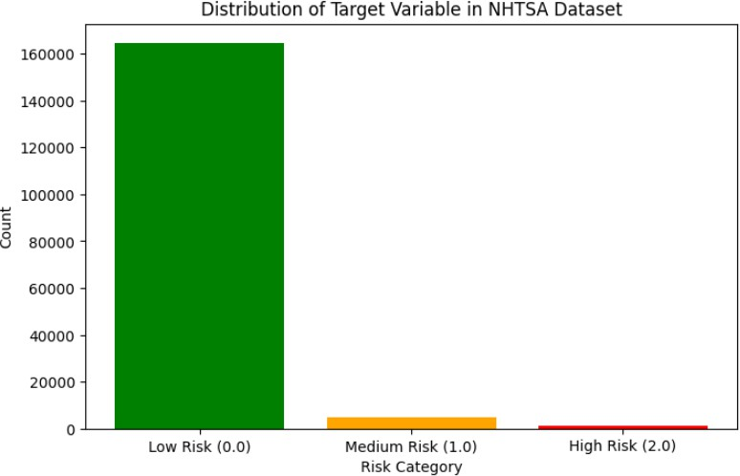

Figure 1. Target Variable Distribution

The bar chart above represents the distribution of the Target Variable, showing a significant class imbalance where most of the data belongs to the Low Risk (0.0) category, while Medium Risk (1.0) and High Risk (2.0) are highly underrepresented. This imbalance can lead to biased predictive models that fail to correctly identify medium- and high-risk instances. To address this, we plan to implement resampling techniques such as oversampling the minority classes using SMOTE and under sampling the majority class to achieve a more balanced distribution. Additionally, we will explore cost-sensitive learning by assigning higher misclassification penalties to medium- and high-risk categories, ensuring the model places more emphasis on identifying them correctly. Furthermore, synthetic data augmentation will be employed to generate additional samples for the underrepresented classes, improving overall model performance. By applying these strategies, we aim to develop a robust and fair model that accurately represents all risk levels, enhancing its real-world applicability.

Exploratory Data Analysis

Exploratory Data Analysis (EDA) is a crucial step in understanding the underlying patterns, trends, and distributions within the dataset before building predictive models. This process involves visualizing key variables, identifying data imbalances, detecting anomalies, and uncovering relationships to guide data preprocessing and feature engineering.
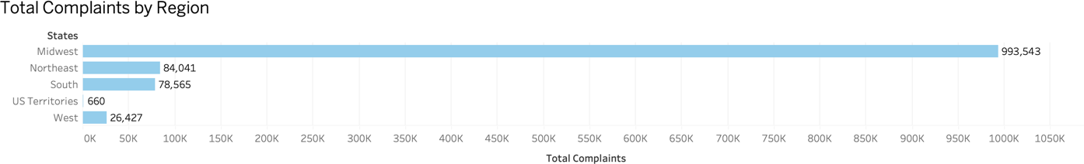

Figure 2. Total Complaints by Region

The bar chart visualizes the total number of complaints reported across different U.S. regions. The Midwest has the highest number of complaints (993,543), significantly surpassing other regions. The Northeast (84,041) and South (78,565) have similar complaint counts, while the West (26,427) and US Territories (660) report the fewest complaints. The disparity may be due to population density, vehicle usage, reporting mechanisms, or regional driving conditions.
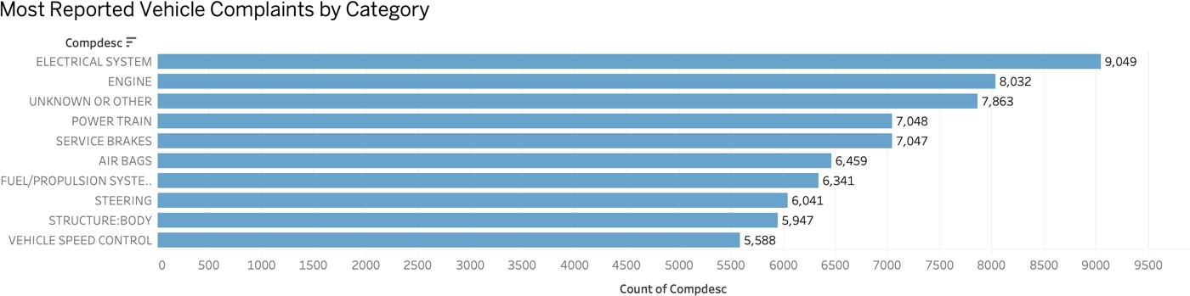

Figure 3. Most Reported Vehicle Complaints by Category

This horizontal bar chart visualizes the most frequently reported vehicle complaints, categorized by complaint description (COMP_DESC). The Electrical System has the highest number of complaints (9,049), followed by Engine Issues (8,032) and Unknown or Other Issues (7,863). Other major concerns include Power Train (7,048), Service Brakes (7,047), and Air Bags (6,459). This insight helps identify key problem areas in vehicle safety and reliability, which could be useful for manufacturers, regulators, and policymakers in prioritizing improvements and recalls.
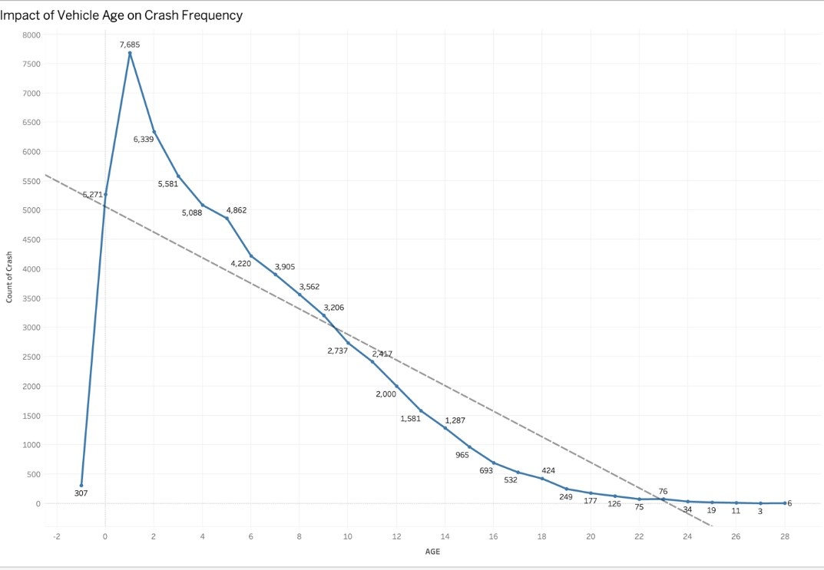

Figure 4. Impact of Vehicle Age on Crash Frequency

This chart shows the number of crashes based on vehicle age at the time of the complaint. The trend peaks at 1-year-old vehicles, with crashes declining as vehicles age. The negative correlation suggests that newer vehicles are involved in more reported crashes, likely due to higher usage, manufacturer defects, or inexperienced drivers. Older vehicles may have fewer complaints due to lower usage or retirement from active service

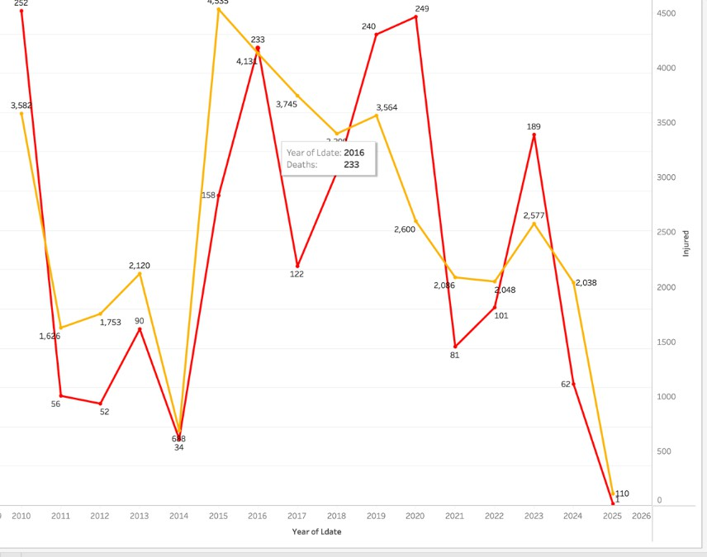

Figure 5. Yearly Trends in Reported Crash Deaths and Injuries

This chart compares reported deaths (red) and injuries (orange) from crashes over the years. Injuries consistently outnumber deaths, with peaks in 2016 (4,535 injuries) and 2019 (3,564 injuries). Fatalities were highest in 2010 (252 deaths) and 2020 (249 deaths) but have shown a decline in recent years. The fluctuations suggest factors like vehicle safety improvements, policy changes, or variations in reporting.

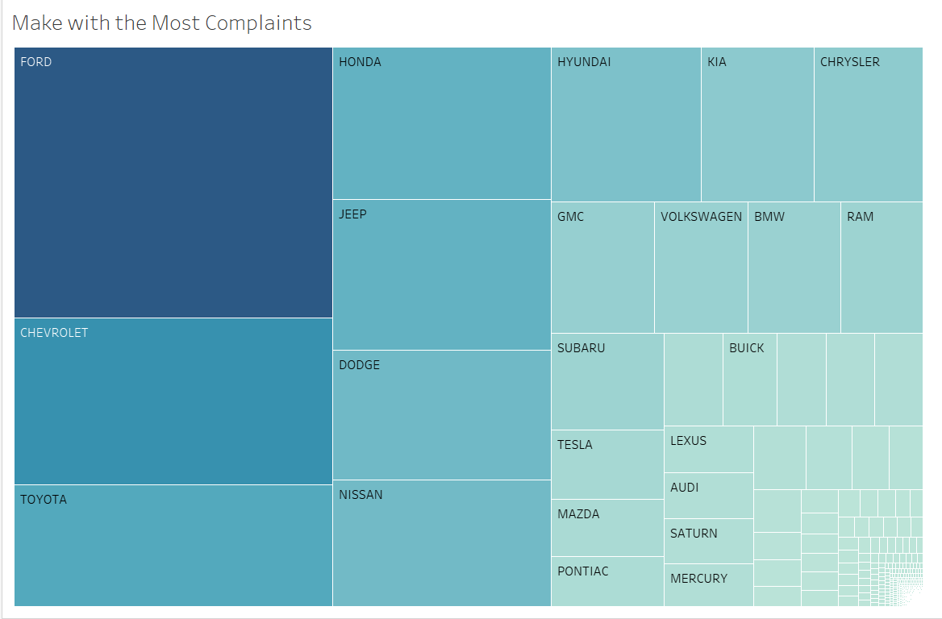

Figure 6. Identifying the Automakers with the Most Complaints

A tree map highlighting the automakers with the most complaints is the first visualization. The top carmaker with the most complaints is Ford, which is followed by Chevrolet, Toyota, and Honda. Notably, there are a lot of complaints about companies like Chrysler, Hyundai, and Kia. The manufacturer has received more complaints for larger blocks, which suggests areas of concern that need more thorough investigation.

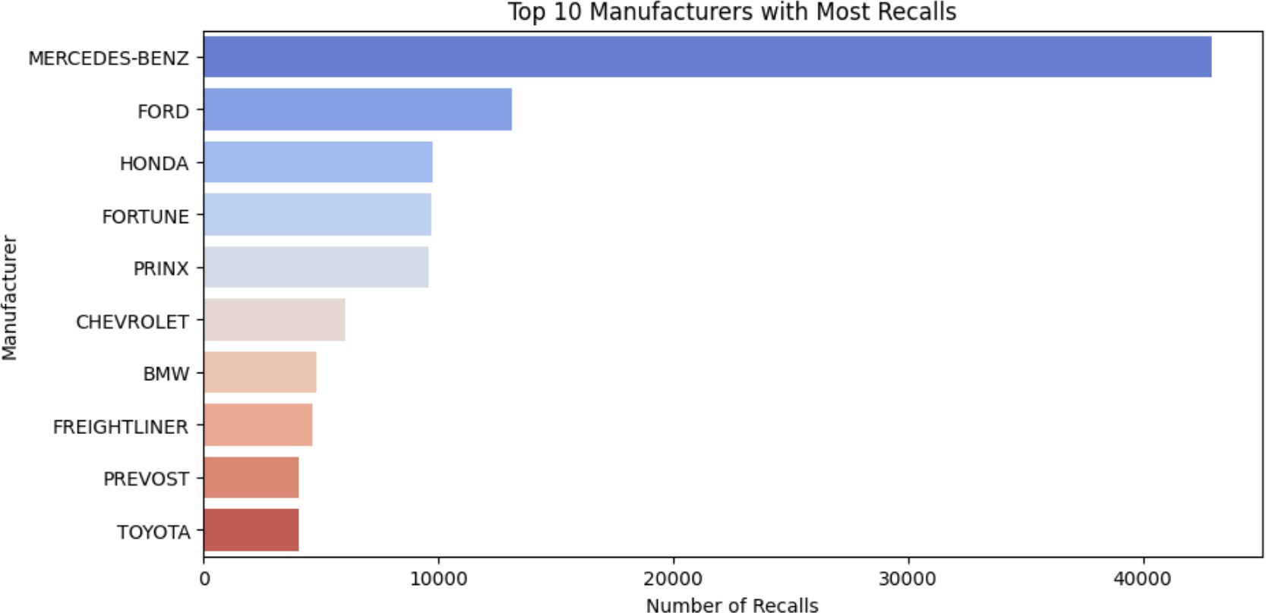

Figure 7. Complaint Trends Over Time

The bar chart displays the top ten manufacturers with the highest number of recalls. Mercedes-Benz leads by a significant margin, followed by Ford and Honda, indicating a high frequency of reported defects. In the previous visualization we saw that Ford has the highest number of complaints but Benz leads in the race of having highest recalls by a great margin. This shows us that complaints may not always turn into recall and there may genuinely not be any defect in the design itself. Other major manufacturers, including Chevrolet, BMW, and Toyota, also appear, suggesting that recalls are widespread across both luxury and mainstream brands. The data highlights the scale of recalls in the automotive industry and underscores the need for manufacturers to enhance quality control and safety measures.

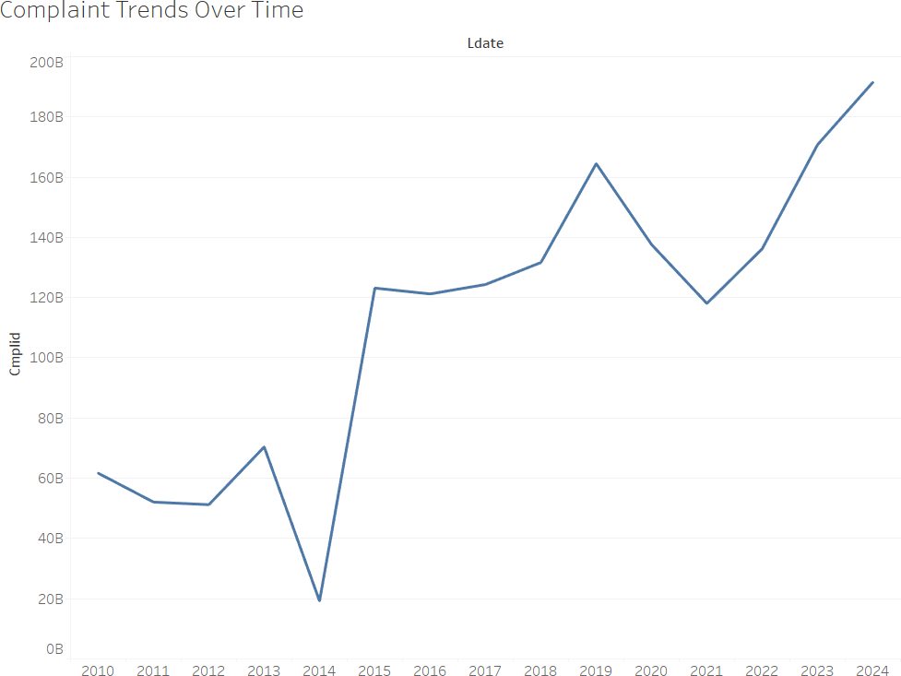

Figure 8. Complaint Trends Over Time

A time-series analysis of vehicle complaints over time is shown in the second visualization. There is a definite upward trend, suggesting that vehicle complaints increased starting in 2010. The years 2018–2023 see the highest number of complaints, which may indicate a rise in car problems, increased consumer awareness, or better reporting systems. A steep drop in 2025, though, can point to missing data for that year.
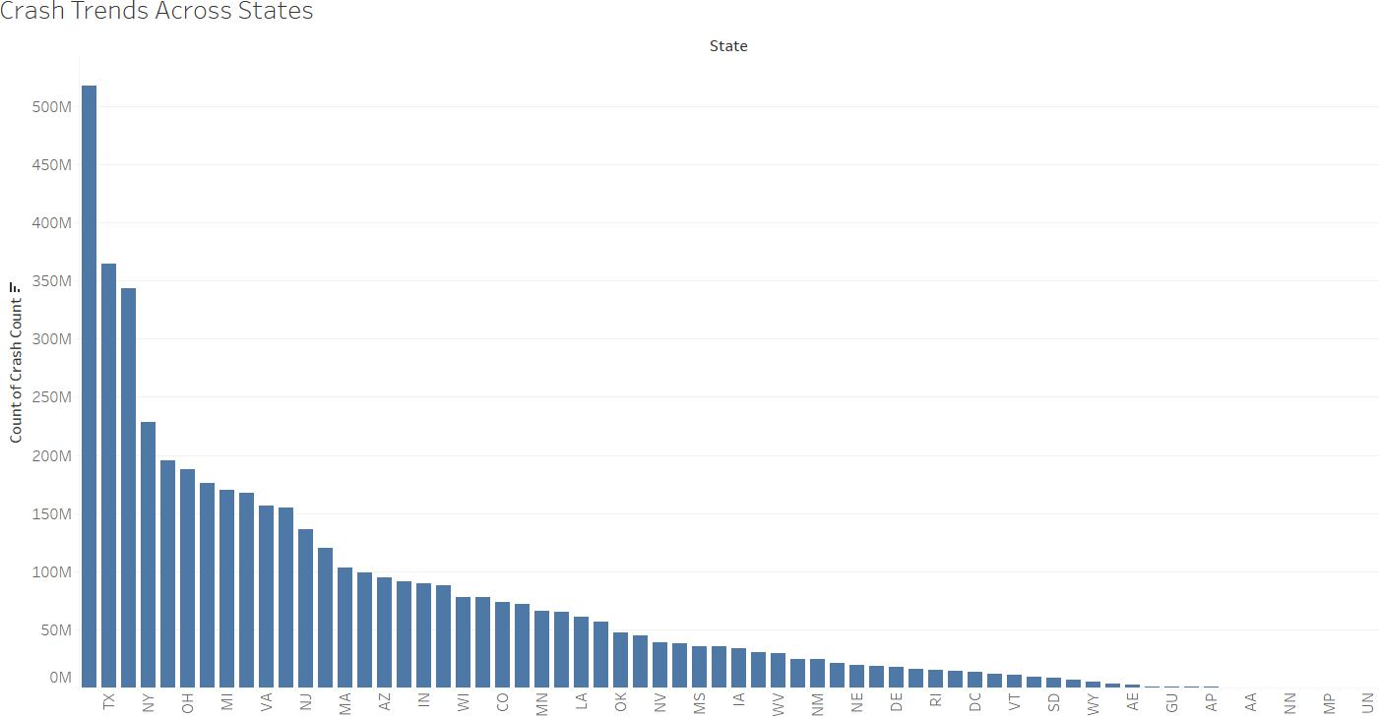

Figure 9. Crash Trends Across States

California has more than 500 million crashes, which is probably because of its large population, congested roads, and big cities like Los Angeles. Due to their busy roads, tourist attractions, and urban centers, Florida and Tennessee also have high crash rates. In line with their rural, less crowded settings, smaller, less populous states like North Dakota, Wyoming, and Vermont report fewer crashes.
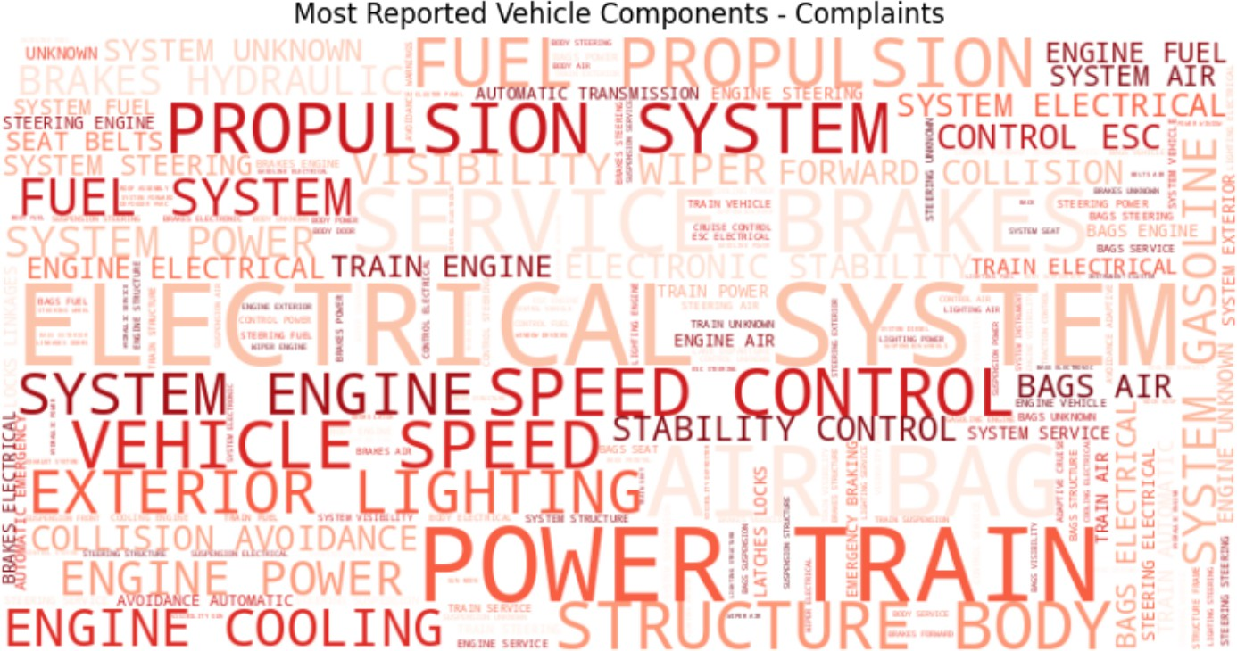

Figure 10. Complaint Trends Regarding Vehicle Components

The word cloud highlights the most frequently reported vehicle components in consumer complaints. Powertrain, fuel system, and electrical system appear most often, indicating common failure points. Issues with the engine, speed control, and braking system suggest concerns about performance and safety. Mentions of collision avoidance and stability control point to problems with driver assistance systems. The findings emphasize the need for manufacturers to address these critical areas to improve vehicle reliability and safety

Data Preprocessing and Transformation

Handling Missing Values

Ensuring data completeness and accuracy is crucial for reliable analysis and model performance. A thorough examination of the dataset was conducted to identify missing values across all features. Attributes with a high percentage of missing values were either dropped or imputed, depending on their relevance to the study and the feasibility of deriving meaningful replacements.
Columns with more than 90% missing values were removed to prevent distortions in analysis. The excluded columns include PURCH_DT, FUEL_SYS, TRANS_TYPE, DOT, TIRE_SIZE, LOC_OF_TIRE, TIRE_FAIL_TYPE, ORIG_EQUIP_YN, MANUF_DT, SEAT_TYPE, RESTRAINT_TYPE, DEALER_NAME, DEALER_TEL, DEALER_CITY, DEALER_STATE,
DEALER_ZIP, and REPAIRED_YN. These attributes had a minimal impact on the study's objectives, and their imputation would have introduced additional noise, compromising data integrity. Furthermore, VIN, NUM_CYLS, and MFR_NAME were excluded due to their high number of missing values and lack of direct relevance to complaint analysis.
To maintain the consistency of primary keys, records where MAKETXT, MODELTXT, YEARTXT, or COMPDESC were missing were eliminated. Since the CDESCR (Complaint Description) forms the backbone of text analysis and classification, all rows lacking complaint descriptions were also removed. Additionally, model years labeled as 9999 and complaints where MAKETXT or MODELTXT were marked as "UNKNOWN" were excluded to ensure analytical relevance. Complaints involving vehicle models manufactured before 1995 were also removed to focus on more recent trends in automotive defects and recalls.

Data Imputation

After handling missing values, an appropriate imputation strategy was applied to selected attributes to maintain dataset consistency.

Mileage (MILES) Imputation

The MILES column exhibited missing values, outliers, and extreme values that could distort the analysis. Negative mileage values (e.g., -95,000 miles) and excessively high values exceeding 400,000 miles were identified and removed. To facilitate more effective imputation, a new feature, AGE, was introduced, calculated as the difference between the complaint filing date (LDATE) and the vehicle model year (YEARTXT). This feature allowed grouping vehicles into age-based categories, ensuring a more realistic estimation of missing mileage values. Missing MILES values were imputed using the mean mileage of vehicles within the same age group. Additionally, a new column, MILES_NEW, was created to retain the imputed values while preserving the original mileage records.

Occurrences (OCCURRENCES) Imputation

The OCCURRENCES attribute, which captures the frequency of reported complaints, had missing values that required careful handling. Analyzing the distribution showed that most vehicles reported 1 or 2 occurrences, with some complaints exhibiting unusually high values. To mitigate inconsistencies, missing values were imputed using median imputation, grouped by MAKETXT, MODELTXT, YEARTXT, and COMPDESC. The median was selected to minimize the influence of extreme outliers. A new column, OCCURRENCES_NEW, was introduced to store the imputed values while retaining the original data for reference.

Vehicle Speed (VEH_SPEED) Handling

The VEH_SPEED column contained some missing and inconsistent values. Speeds below 0 mph and above 200 mph were deemed invalid and subsequently removed from the dataset. Given the contextual nature of vehicle speed and the potential inaccuracies in assuming missing values, it was decided not to impute missing speeds. Instead, records with missing speed values were retained to ensure unbiased analysis.

Feature Engineering

To enhance the dataset's predictive capability and uncover hidden patterns, new features were engineered from the existing data. These newly derived attributes provide a deeper understanding of complaint characteristics and enable the model to capture key relationships more effectively.
Key Features Created

Vehicle Age (AGE)

The AGE feature was derived to measure the age of a vehicle at the time of a complaint. It was calculated as:
AGE=LDATE−YEARTXT

This attribute plays a vital role in analyzing how vehicle aging impacts complaint frequency. Older vehicles tend to exhibit more mechanical failures, while newer models may reveal manufacturing defects that trigger early recalls.
Time to Report (TIME_TO_REPORT)

The TIME_TO_REPORT feature measures the number of days between the incident occurrence and official complaint filing:
TIME_TO_REPORT=FAILDATE−LDATE

This metric helps assess the urgency of complaints. Shorter reporting durations may indicate critical safety issues, whereas longer durations suggest complaints related to minor defects or gradual wear and tear.

Regional Classification

To analyze geographic variations in vehicle complaints, all U.S. states were categorized into five regional groups:
- NORTHEAST_STATES

- MIDWEST_STATES

- SOUTH_STATES

- WEST_STATES

- US_TERRITORIES

For each region, a binary column was created to facilitate regional analysis of defect trends. This classification allows for identifying regional differences in safety issues based on climate, road conditions, and manufacturer presence.

Quarterly Trends Analysis

To explore seasonal variations in defect reporting, the complaint filing date (LDATE) was used to extract quarterly classifications:

- Q1_TOTAL (January – March)

- Q2_TOTAL (April – June)

- Q3_TOTAL (July – September)

- Q4_TOTAL (October – December)

This helps uncover trends where certain defects might peak during specific seasons, such as cold-weather engine failures in winter or overheating issues in summer.

Pivoting Categorical Features

Several categorical variables were transformed into binary indicators to enhance interpretability:

- Complaint Type Pivoting: Columns such as CT_IVOQ_COUNT, CT_EVOQ_COUNT, CT_LETR_COUNT, CT_SVOQ_COUNT, and CT_CON_COUNT were created to capture complaint sources.
- Drive Train and Fuel Type Pivoting: Separate features were created for DT_FWD_SUM, DT_4WD_SUM, DT_AWD_SUM, DT_RWD_SUM (drive trains) and FT_GAS_COUNT, FT_BIFUEL_COUNT, FT_DIESEL_COUNT, FT_HYBRID_ELECTRIC_COUNT (fuel
types).

- Product Type Pivoting: Complaints were categorized into PT_VEHICLE, PT_EQUIPMENT, PT_CHILD_RESTRAINT, and PT_TIRES based on the nature of the reported issue.
These transformations provide structured insights and facilitate aggregated analysis of different defect categories.

Data Aggregation

To standardize the dataset at the complaint level, all records were grouped by the primary keys MAKETXT, MODELTXT, YEARTXT, and COMPDESC. This ensured that all related complaints were consolidated for efficient analysis.
Aggregation operations were applied to derive summary statistics for key features:

- Total Complaints: Count of CMPLID for each vehicle model and defect type.

- Crash, Fire, and Police Reports: Summing CRASH, FIRE, and POLICE_RPT_YN to assess severity.
- Ownership & Mechanical Attributes: Summing OWNERSHIP, ANTI_BRAKES_YN, CRUISE_CONT_YN to evaluate patterns in vehicle failures.
- Medical and Towing Incidents: Capturing the frequency of MEDICAL_ATTN and VEHICLES_TOWED_YN cases.
- Regional and Seasonal Trends: Summing Q1_TOTAL, Q2_TOTAL, Q3_TOTAL, Q4_TOTAL to analyze seasonal recall patterns.
Mean, max, and median values were also computed for VEH_SPEED, AGE, MILES, and OCCURRENCES, enabling further quantitative risk assessment of vehicle defects. By implementing a structured approach to handling missing data, feature engineering, and aggregation, the dataset was transformed into a clean, structured, and insightful format. These modifications enable enhanced predictive modeling and effective recall prioritization, ensuring better insights into vehicle safety issues. The recall and investigation datasets were also standardized to the complaint level by aggregating them using the primary keys (MAKETXT,

MODELTXT, YEARTXT, COMPDESC). These datasets were then merged with the imputed and aggregated complaints dataset, enabling the creation of the target variable based on historical recall and investigation outcomes.

Assumption Tests

Assumption tests play a critical role in statistical analysis and data modeling, ensuring the validity, reliability, and interpretability of results. These tests assess whether a dataset aligns with the theoretical requirements necessary for accurate inferences and predictions. Violating these assumptions can lead to biased estimates, incorrect p-values, and diminished model performance. In this project, we focused on four key assumptions—Normality, Homoscedasticity, Multicollinearity, and Independence of Observations, which are fundamental for parametric statistical methods and regression-based modeling.

Normality

The normality test was conducted to check whether the numerical variables in the dataset follow a bell-shaped, symmetric distribution. To assess normality, the Kolmogorov-Smirnov (KS) test was conducted on all numerical variables. The test results indicate that all variables have a p-value of less than 0.05, meaning they significantly deviate from a normal distribution. This suggests that the dataset is non-normally distributed. Visual inspection through histograms could further confirm skewed distributions for key variables like VEH_SPEED and AGE.
The results showed that all variables deviate significantly from normality, meaning they do not follow a typical smooth distribution. The histograms further confirm this issue, with some variables, such as CMPLID and FAILDATE, showing irregular patterns that may indicate data entry inconsistencies or categorical encoding. The YEARTXT variable is highly skewed, meaning most

values are concentrated on one side rather than being evenly spread. Similarly, AGE and VEH_SPEED exhibit peaks and fluctuations, suggesting an uneven distribution. Additionally, variables like INJURED and DEATHS contain mostly zero values, with only a few cases having larger numbers, making them highly imbalanced.
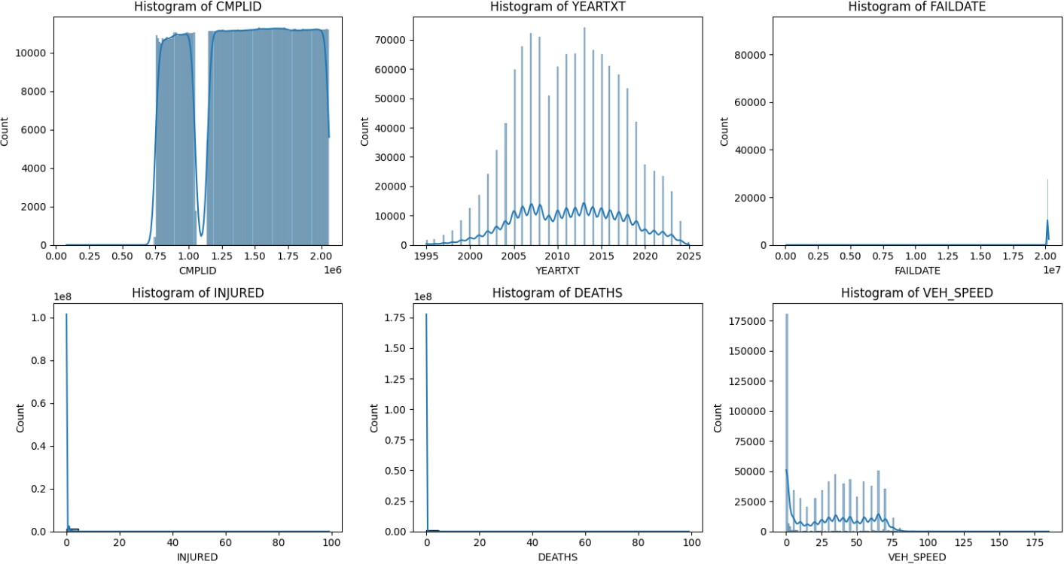

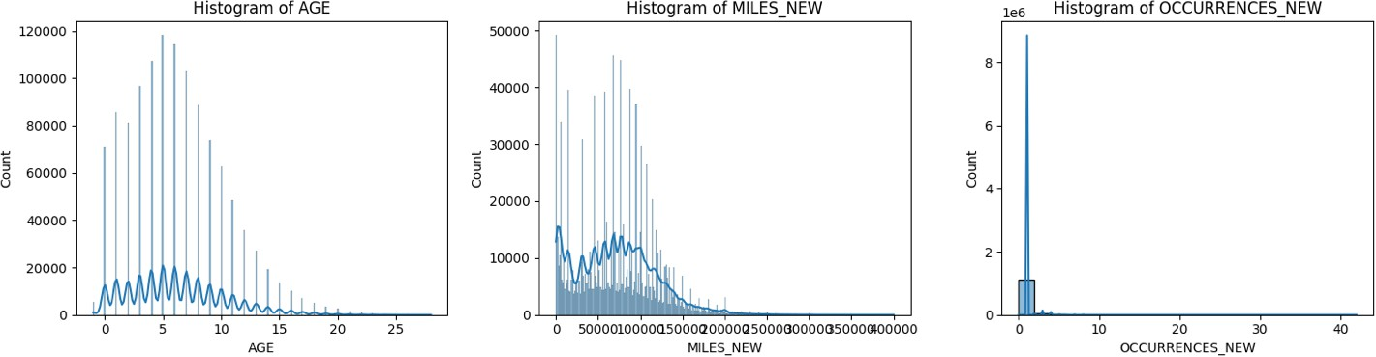

Figure 11. Box Plots for Normality of Variables

Since normality is a key assumption in many statistical models, applying standard methods without adjustments could lead to misleading results. Given these deviations, appropriate data

measures may be required to meet the assumptions of normality for downstream statistical modeling and analysis. In this study, we used XGBoost, a tree-based ensemble learning method that does not rely on distributional assumptions like normality or linearity. This allowed us to effectively model the data as-is, accommodating skewed or irregular distributions while maintaining strong predictive performance. By leveraging XGBoost’s ability to handle non-parametric relationships, we bypassed the need for normalization techniques typically required for linear models.

Homoscedasticity

Homoscedasticity, or equal variance, ensures that all levels of the independent variables have the same residual variance, which is essential for regression models and parametric tests to produce unbiased estimates and reliable statistical conclusions. Violations of this assumption, known as heteroscedasticity, can lead to inefficient models and misleading results.
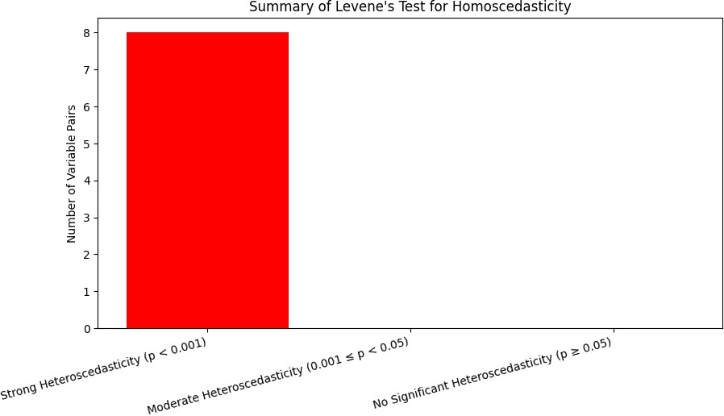

Figure 12. Levene’s Test Results

Levene’s test for homoscedasticity across variable pairs revealed that all tested pairs exhibit significant heteroscedasticity (p < 0.05), indicating substantial variance inequality across the dataset. This suggests that the dataset contains inconsistent spread of values, which can impact statistical modeling. Given this widespread heteroscedasticity, it is necessary to consider robust techniques such as transforming the data (e.g., log or Box-Cox transformations) or using heteroscedasticity-consistent standard errors to improve model reliability

Multicollinearity

Variance Inflation Factor (VIF) measures how much a variable is correlated with other independent variables in a dataset. High VIF values indicate multicollinearity, meaning a variable is strongly related to others, which can cause instability in regression models and make it difficult to determine the true effect of each predictor.
In this dataset, all variables have VIF values below 5, suggesting that multicollinearity is not a major concern. AGE (2.31) and MILES_NEW (1.99) have the highest VIF values, but they are still within an acceptable range, meaning they do not exhibit severe collinearity. YEARTXT (0.83) has particularly low VIF, which could indicate it has little correlation with the other variables. Overall, these results suggest that independent variables are relatively independent of each other, making them suitable for regression modeling without major multicollinearity concerns.

Independence of Observations

The independence of residuals is crucial for reliable regression analysis. The dataset has no duplicate rows, ensuring unique observations. However, the Durbin-Watson test statistic

(0.57792) indicates strong positive autocorrelation, meaning the residuals are highly correlated. This violates the independence assumption, potentially leading to underestimated standard errors and misleading statistical conclusions. To address this, techniques like adding lagged variables, using generalized least squares, or applying robust standard errors may be needed.

Correlation Matrix for Linearity

The correlation matrix assesses the linear relationships between numerical variables, helping to identify strong dependencies. The results show that CMPLID and YEARTXT (0.71) and CMPLID and FAILDATE (0.56) have moderate to strong positive correlations, indicating that these variables are closely related. Similarly, AGE and MILES_NEW (0.70) suggest that as vehicle age increases, mileage also tends to rise. In contrast, strong negative correlations are observed between YEARTXT and AGE (-0.69) and YEARTXT and MILES_NEW (-0.49), implying that older vehicles are associated with earlier years and lower mileage. Most other correlations are weak or near zero, such as INJURED and VEH_SPEED (0.008) and DEATHS and VEH_SPEED (0.004), suggesting that vehicle speed has little linear relationship with injuries or fatalities.

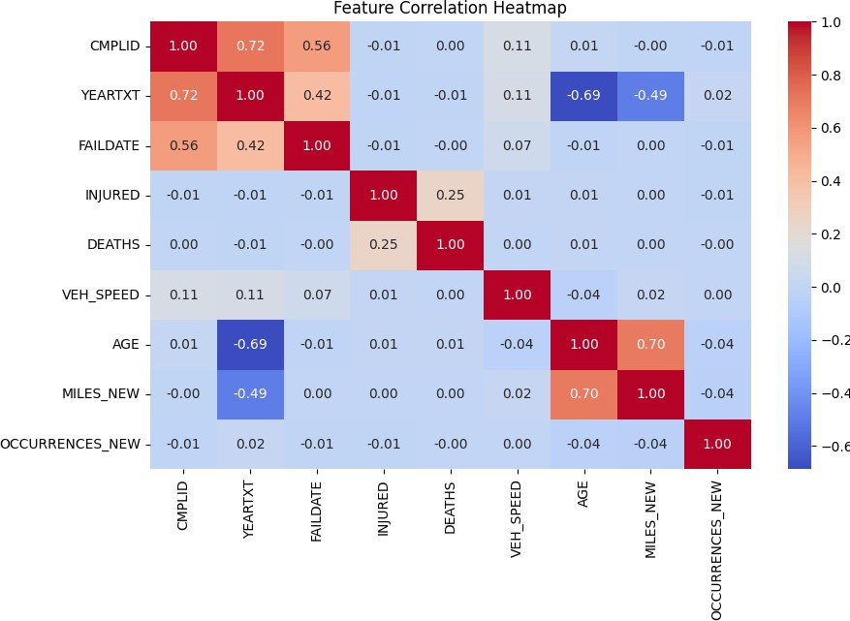

Figure 13. Feature correlation Heatmap

Overall, while a few variables exhibit strong correlations that may require further analysis for multicollinearity, most relationships are weak, indicating that linearity assumptions may not hold strongly for all features. Appropriate transformations or alternative modeling approaches might be needed for regression analysis.

Data Modelling

This section describes the process for creating a machine learning model aimed at classifying vehicle complaints according to risk, facilitating proactive recall management. Initially, feature engineering combines structured numerical data—such as vehicle details, recall history, and investigation status—with unstructured text data processed using BERT embeddings to capture

nuanced complaint severity. The modeling phase will focus primarily on XGBoost, given its effectiveness with imbalanced data, while neural networks are noted as potential future enhancements for handling complex textual information. Model performance will be rigorously assessed using accuracy, precision, recall, F1-score with cross-validation ensuring robust generalization. Ultimately, the developed classification model will leverage integrated text-based risk scores from BERT embeddings alongside numerical features, optimizing the accuracy and reliability of risk-level predictions.

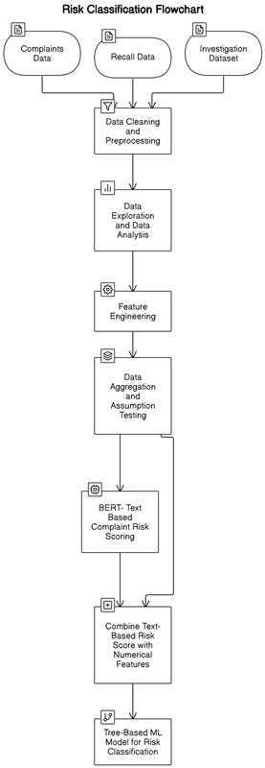

Figure 14. Proposed Risk Classification Workflow with Multiple Model Architecture

NLP-Based Neural Network Analysis of Complaint Descriptions

The NHTSA complaint dataset contains a wealth of unstructured textual information in the form of consumer-submitted complaint descriptions (CDESCR). While traditional machine learning pipelines rely heavily on structured features (e.g., MAKETXT, MODELTXT, YEARTXT), they often overlook the latent patterns embedded in free-text fields. These textual narratives frequently contain early indicators of mechanical failures or safety risks that are not captured by categorical variables alone. Therefore, leveraging this unstructured information requires the application of Natural Language Processing (NLP) techniques capable of converting text into a structured, machine-readable format.
To achieve this, we used the Sentence-BERT (SBERT) model, a transformer-based architecture optimized for sentence-level semantic similarity. SBERT converts each complaint description into a fixed-length dense vector embedding (768 dimensions) that captures its contextual and semantic meaning. These embeddings form a high-dimensional representation of the text that preserves relationships between concepts (e.g., "brake failure" and "loss of braking power") even if exact words differ.
Once the embeddings were generated, they were fed into a fully connected deep neural network (DNN). The neural network architecture was specifically designed to capture nonlinear relationships between semantic features in the embedding space and the target risk labels (0: low risk, 1: investigation, 2: recall). The network used ReLU activation functions, dropout layers for regularization, and a final softmax layer for multiclass classification. The model was trained using the categorical cross-entropy loss function and optimized using the Adam optimizer.

Data Preprocessing and Text Cleaning

We applied a systematic text-cleaning pipeline to standardize the free-form complaint narratives. This included:
- Removing HTML tags and URLs.
- Replacing non-ASCII characters to prevent encoding errors.
- Stripping extra whitespace and punctuation for uniformity.
Each entry in the CDESCR column was transformed into a cleaned version called cleaned_text.

Sentence Embedding Using SBERT

We utilized the sentence-transformers/all-MiniLM-L6-v2 model from the Sentence Transformers library. This pre-trained model generates dense vector representations (embeddings) that capture semantic meaning at a sentence level.
- Each complaint description was encoded into a 768-dimensional embedding vector.

- The embedding process was performed in batches of 256 using GPU acceleration to speed up computation.
- These embeddings were stored in new columns ranging from embedding_0 to embedding_767.
The resulting embedding matrix captures nuanced linguistic features from the complaint descriptions, allowing downstream machine learning models to differentiate between varying complaint severities.

Data Merging and Cleaning Steps:

Aggregation: Complaint embeddings were grouped by key identifiers — MAKETXT, MODELTXT, YEARTXT, and COMPDESC. For complaints repeated across multiple rows, the mean of their embedding vectors was used to form a unique representation per vehicle-component-year combo.
Standardization: Make, model, and complaint descriptions were standardized using regular expressions to ensure exact matching with target datasets.
Join Operation: The aggregated complaint embeddings were then merged with the labeled target file using a left join on the standardized keys.
Missing Target Handling: Complaints that couldn’t be linked to any investigation or recall were labeled as class 0 (low risk), resulting in the following distribution:
Class 0: 164,566 records

Class 1: 4,750 records

Class 2: 1,109 records

This imbalanced target setup reflects the real-world rarity of escalations but poses modeling challenges addressed through appropriate metrics and class weighting.

Deep Learning Model Architecture

We built a fully connected feedforward neural network using TensorFlow and Keras, leveraging the semantic embeddings as input features and the three-level risk category as the output. The input to the model consisted of 768-dimensional embeddings generated from preprocessed complaint text, capturing the contextual meaning and nuance of each complaint. The architecture included multiple dense layers with ReLU activation functions to introduce non-

linearity, and dropout layers were strategically applied to prevent overfitting and enhance generalization. The final output layer used a Softmax activation function to predict the probability distribution over three distinct classes: High, Medium, and Low risk.
The model was compiled using the Adam optimizer for efficient gradient descent and categorical cross entropy as the loss function to handle the multiclass classification task. Performance was monitored using both accuracy and classification report to assess the model’s ability to distinguish between classes, especially in the presence of class imbalance. Additionally, early stopping was employed based on validation loss to ensure optimal training and prevent overfitting, making the model both robust and efficient for real-world applications.

Table 4.
Detailed Architecture and Training Configuration
Component | Details
Input Layer | 768-dimensional vector (precomputed complaint text embedding)
Hidden Layer 1 | Dense Layer with 500 neurons, ReLU activation, Dropout (rate = 0.3)
Hidden Layer 2 | Dense Layer with 250 neurons, ReLU activation, Dropout (rate = 0.2)
Hidden Layer 3 | Dense Layer with 100 neurons, ReLU  activation
Hidden Layer 4 | Dense Layer with 50 neurons, ReLU  activation
Output Layer | Dense Layer with 3 neurons, Softmax  activation for multiclass classification
Loss Function | categorical_crossentropy
Optimizer | Adam
Evaluation Metrics | Accuracy, AUC (Area Under the Curve for  multiclass classification)
Target Encoding | One-hot encoded using to_categorical()
Training/Testing Split | 80% training / 20% testing
Early Stopping | Enabled, based on validation loss to prevent overfitting

Deep learning Model Training and Performance

The model showed promising learning behavior with increasing AUC across epochs, peaking at ~0.92 on the training set and ~0.82 on the validation set within 10 epochs. The training stopped early at epoch 10 based on the early stopping callback to prevent overfitting. Predicted class probabilities for all complaints were stored in a final dataset containing:
- Vehicle identifiers (MAKETXT, MODELTXT, YEARTXT, COMPDESC)

- Predicted probability scores for all 3 classes (e.g., prob_low, prob_medium, prob_high) These scores were exported as CSVs and form the basis for integration with other machine learning models or downstream decision-making systems.

Data Preparation for Model Building

To build a comprehensive classification framework, we strategically prepared the dataset by integrating outputs from the deep learning model with structured vehicle complaint metadata. This hybrid approach leverages the strengths of both Natural Language Processing (NLP) and traditional machine learning by combining semantic insights with categorical and temporal features.

Integration of NLP Outputs with Structured Data

Following the training and inference phase of the neural network, the output probabilities from the final Softmax layer—prob_low, prob_medium, and prob_high—were extracted. These values represent the model’s confidence scores for each of the three risk categories associated with a vehicle complaint. These probabilistic scores offer nuanced semantic signals derived from the original textual descriptions of complaints.

To prepare for model training and evaluation, the enriched dataset was partitioned into training and testing subsets using an 80/20 split:
Training Set: 135,286 records Test Set: 33,822 records
This stratified split was designed to ensure that each class was proportionally represented in both the training and test sets. Holding out a dedicated test set enabled robust evaluation of model generalizability and mitigated the risk of overfitting. The core objective of this phase was to construct a reliable multiclass classification system capable of predicting complaint severity and estimating the likelihood of a complaint resulting in a safety recall or formal investigation. To achieve this, multiple machine learning algorithms—including logistic regression, random forests, and gradient boosting classifiers—were trained on the combined dataset. The addition of deep learning-derived features significantly enhanced the model’s ability to capture complex textual patterns that may be missed by traditional statistical models alone.

Understanding XGBoost

XGBoost (Extreme Gradient Boosting) is an advanced machine learning algorithm based on gradient-boosted decision trees. It improves model performance by combining the outputs of multiple weak learners (trees), with each iteration correcting the errors of the previous ensemble. The objective function optimized by XGBoost includes both:
- A loss function that measures the model’s fit (e.g., log-loss for classification), and

- A regularization term that penalizes model complexity, helping prevent overfitting.

Objective Function:

𝑂𝑏𝑗(𝜃) = 𝛴 𝐿(𝑦𝑖, ŷ𝑖) + 𝛴 𝛺(𝑓𝑘)
− L(yi, ŷi) is the loss function for predicted vs. true label

- Ω(fk) is the regularization term on each tree
- T is the number of boosting rounds (trees)
At each boosting round t, a new tree ft(x) is added such that:

ŷ(t) = ŷ(t−1) + η ft(x)

Where η is the learning rate.

Hyperparameter Tuning with Random Search

To fine-tune the XGBoost classifier, we applied RandomizedSearchCV, a hyperparameter tuning technique that samples a subset of parameter combinations for efficiency and coverage.

Why Random Search?

- Faster than Grid Search for large parameter spaces

- Still effective at finding near-optimal hyperparameters

- Avoids unnecessary computation on low-impact parameters Random Search Configuration:
- 2-fold cross-validation

- Scoring Metric: roc_auc_ovr_weighted

- Evaluated 60 randomly selected combinations

Table 5.
Parameter grid for gridsearch

Parameter | Values Considered
n_estimators | [100, 300, 500]
max_depth | [3, 5, 7]
reg_lambda | [0.01, 0.1, 1, 10]
learning_rate | [0.01, 0.05, 0.1, 0.15]
reg_alpha | [0, 0.1, 0.5, 1]

Table 6.
Optimal hyperparameter identified after 60 trials

Parameter | Optimal Value
n_estimators | 500
max_depth | 5
reg_lambda | 1
learning_rate | 0.01
reg_alpha | 0.5

These hyperparameters offered the best trade-off between predictive performance and model generalization on unseen complaint data.

XGBoost Model Variants and Evaluation

To accurately classify vehicle complaints into High, Medium, and Low risk categories, multiple XGBoost model variants were developed and evaluated. These models differed in their handling of class imbalance through techniques such as hyperparameter tuning, class weighting, and sampling strategies.
Each model was assessed based on key performance metrics including overall accuracy, class-wise recall, and macro-averaged F1 scores to understand trade-offs between precision and class-specific detectioncapabilities.

Below is a detailed summary of each model tested:

Table 7.
Model Summary

Model | Accuracy | Macro F1  Score | Recall (Low) | Recall (Medium) | Recall (High) | Key Observations
Model 1 – Baseline | 96.89% | 0.54 | 1.00 | 0.16 | 0.28 | High accuracy but poor minority class detection;  biased toward Low class.
Model 2 – Tuned | 96.87% | 0.50 | 1.00 | 0.13 | 0.20 | Minor tuning gains; still heavily biased toward  majority class.
Model 3 – Class Weights | 81.75% | 0.42 | 0.82 | 0.61 | 0.76 | Balanced recall across classes but decreased precision and  accuracy.
Model 4 – Log Weights | 57.60% | 0.34 | 0.57 | 0.87 | 0.57 | Overcompensated minority class; poor overall  accuracy and generalization.
Model 5 – SMOTE +  Undersample | 82.00% | 0.42 | 0.83 | 0.56 | 0.80 | Strong recall balance; retained decent accuracy; improved class-  level consistency.
SMOTE +  Oversampling | 94.71% | 0.55 | 0.97 | 0.37 | 0.36 | Best macro F1 score and good balance; slight drop in precision for minority classes.

A series of XGBoost-based models were evaluated to address class imbalance and enhance the classification of vehicle complaints into Low, Medium, and High-risk categories. The baseline model (Model 1), trained with default parameters and no class weighting, achieved high overall

accuracy but was heavily biased toward the majority class, resulting in poor recall for Medium and High-risk complaints. Model 2 introduced hyperparameter tuning through grid search, which offered only marginal improvements and failed to adequately resolve the imbalance issue. In Model 3, balanced class weights were applied using scikit-learn’s built-in strategy, leading to notable gains in recall for minority classes, particularly High-risk complaints. However, this improvement came at the expense of reduced overall accuracy and precision, suggesting a tendency to overcompensate. Model 4 adopted a logarithmic weighting approach (log(N/n)), which further intensified this overcompensation, significantly reducing the model's generalization ability and making it unsuitable for deployment. More promising results were observed in Model 5, which combined SMOTE-based synthetic oversampling for minority classes with random undersampling for the majority class. This model achieved the best balance of performance, delivering the highest macro F1 score along with strong recall across all risk levels. Model 6, which used SMOTE along with random oversampling and hyperparameter tuning, showed balanced recall but suffered from decreased precision and overall accuracy. Overall, Model 5 demonstrated the most robust and generalizable performance, making it the preferred strategy for risk classification.
SMOTE + Undersampling
After applying SMOTE and undersampling techniques to address the severe class imbalance (original distribution: Low = 130,048; Medium = 3,702; High = 856), a balanced dataset was created with 856 samples per class. A grid search with 2-fold cross-validation was conducted over 30 parameter combinations (60 total fits).

Table 8.
Final Model Score

Class | Precision | Recall | F1-Score
High Priority | 0.09 | 0.80 | 0.16
Low Priority | 0.99 | 0.83 | 0.90
Medium Priority | 0.12 | 0.56 | 0.20
Accuracy |  |  | 0.82

The classification metrics highlight the model’s strength in identifying high-priority complaints, which is critical in safety-focused applications. While the precision for the High priority class is relatively low at 0.09—indicating a higher number of false positives—the recall is notably high at 0.80. This means the model successfully identifies 80% of actual high-risk complaints, significantly reducing false negatives, which is crucial in this context since missing a true high-risk case could have serious safety implications. In comparison, previous models had much lower recall for high-risk cases, making this model clear improvement. For Low priority complaints, the model performs with exceptional precision (0.99) and strong recall (0.83), indicating reliable identification of less critical cases. Medium priority cases show moderate performance, with a recall of 0.56 and lower precision. Although the overall accuracy is 82%, the key strength of this model lies in its ability to capture high-risk cases effectively, making it highly suitable for proactive recall and safety management.

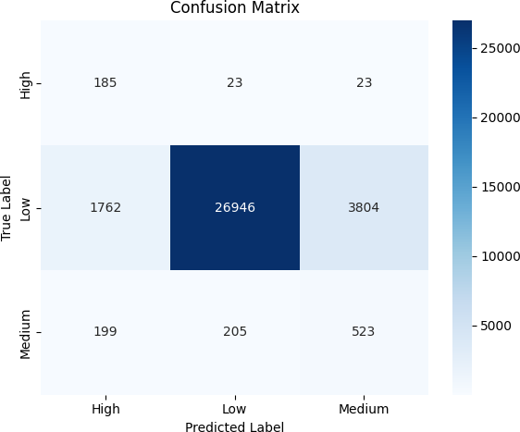

Figure 15. Confusion Matrix

The confusion matrix illustrates how the model performed across the three risk categories by comparing predicted labels to actual labels. For the High priority class, the model correctly predicted 185 instances, while 23 were incorrectly classified as Low and another 23 as Medium. In the case of Low priority complaints, the model showed strong performance, correctly predicting 26,946 instances, although it misclassified 1,762 as High and 3,804 as Medium. For the Medium priority class, 523 instances were correctly classified, while 199 were incorrectly predicted as High and 205 as Low. The matrix uses color intensity to represent the volume of predictions, with darker shades indicating higher counts.

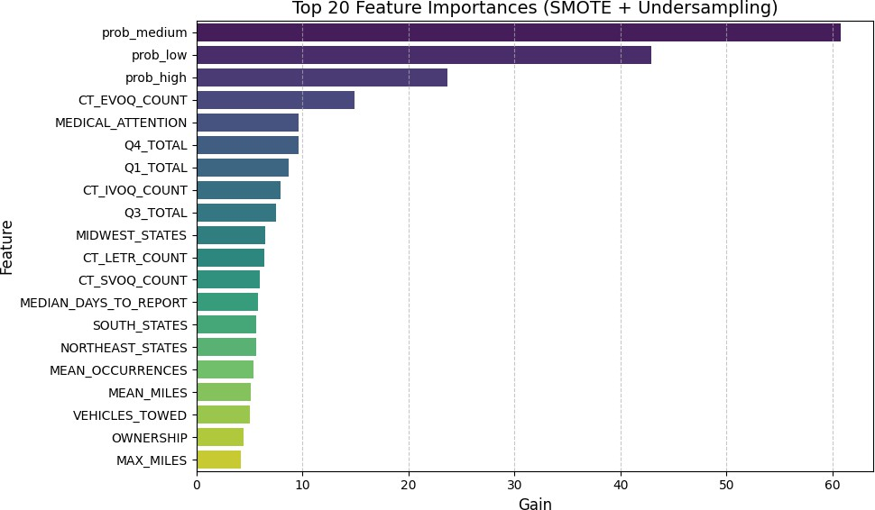

Figure 16. Top 20 Features

The feature importance plot highlights the dominant role of text-derived risk probabilities—prob_medium, prob_low, and prob_high—in classifying complaint risk levels, confirming the value of incorporating BERT-based embeddings. Among the structured features, variables such as CT_EVOQ_COUNT, MEDICAL_ATTENTION, and quarterly complaint volumes (Q1_TOTAL, Q4_TOTAL) also show strong predictive power, indicating that both the source and severity of complaints contribute meaningfully to risk classification. Additional features like regional indicators, reporting delays, and operational usage patterns (e.g., MEAN_MILES, VEHICLES_TOWED) provide contextual depth, emphasizing the multifactorial nature of risk assessment in automotive safety analytics. This model achieved a strong balance in recall across all classes while maintaining decent accuracy. It performed similarly to Model 3 but with better class-level consistency and reduced bias.

Discussions

What key factors in historical recall and complaint data contribute to prioritizing high-risk complaints that might lead to recalls?
The most critical features identified are the probabilistic text-based risk scores derived through BERT embeddings, these text-based probabilities significantly enhance the predictive capability of the model by encapsulating complaint severity based on historical textual patterns. Additionally, numerical features related to complaint types are influential, indicating that the frequency and source of complaints substantially impact the risk assessment. Attributes like the numbers of complaints that need medical attention, number of vehicles towed, and regional indicators also contribute meaningfully, suggesting that the severity and geographical context of incidents are crucial in determining the overall risk. Furthermore, mileage-related metrics and complaint occurrence patterns highlight operational usage, and report delays as notable predictors. This comprehensive analysis underscores the necessity of integrating textual risk assessments with structured complaint data to enable precise, actionable risk classifications and prioritize safety concerns effectively.
The findings from this study have significant implications for advancing proactive vehicle safety management through data-driven decision-making. By successfully demonstrating that machine learning models can predict which complaints are more likely to result in recalls, this research lays the groundwork for more intelligent and responsive automotive safety systems.
For regulatory agencies such as the National Highway Traffic Safety Administration (NHTSA), these models can serve as early warning tools, helping to prioritize investigations based

on complaint risk levels. This could lead to faster identification of systemic defects, reducing the lag time between complaint submission and regulatory action.
For automakers and manufacturers, the ability to assess complaints in real time can support internal quality assurance and compliance workflows. Companies can detect emerging issues sooner, implement preventive measures, and avoid costly recalls or reputational damage. Over time, this can contribute to improved vehicle reliability and enhanced customer trust.

Impact of Vehicle Technological Advancements on Recalls

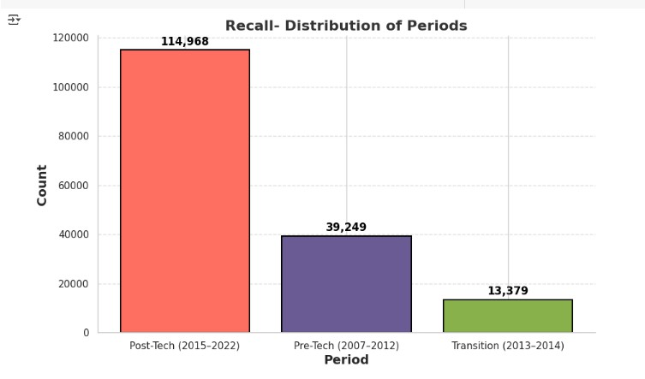

Figure 17. Recall distribution over the years


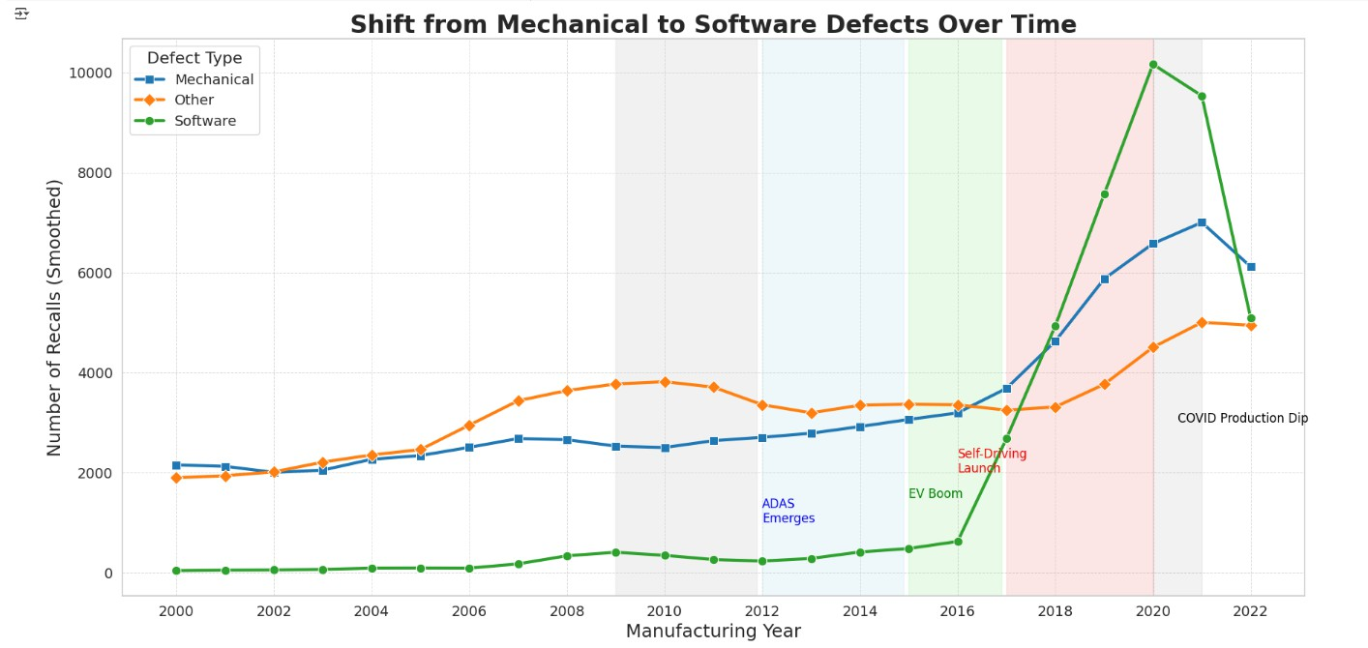

Figure 18. Comparison of mechanical and software defects trend

The analysis of vehicle recall trends clearly illustrates how technological advancements have reshaped automotive safety risks, presenting important implications for stakeholders involved in vehicle safety management, regulatory oversight, and manufacturing processes. Historically, prior to 2012, vehicle recalls primarily revolved around traditional mechanical components like brakes, engines, and suspensions, with stable recall patterns. However, from 2013 to 2014, as Advanced Driver Assistance Systems (ADAS) started gaining prominence, there was a noticeable shift, with recalls beginning to rise due to new technical issues related to sensors and system calibrations. Post-2015 marked a significant transition, driven by widespread adoption of electric vehicles (EVs), semi-autonomous driving, and sophisticated technologies including high-voltage battery systems, over-the-air (OTA) software updates, and AI-driven controls, resulting in a sharp increase in recall volumes. By 2022, recalls nearly tripled compared to the pre-technology period, emphasizing the profound impact technological innovations have had on vehicle reliability and safety. Importantly, the nature of recalls itself has undergone a fundamental shift from mechanical to software-based issues, rising dramatically from merely 1–5% of total recalls before 2015 to nearly 50% by 2020, coinciding with the proliferation of connected systems and autonomous features. This exponential increase in software-related recalls underscores the necessity for stakeholders to refocus their risk management strategies towards robust software validation processes, advanced diagnostic capabilities, and real-time monitoring to effectively address the evolving safety landscape in modern automotive technologies.

Conclusion

This project successfully demonstrated how machine learning and natural language processing (NLP) can be used to strengthen automotive safety efforts by predicting which vehicle complaints are likely to escalate into formal investigations or recalls. By combining structured data with complaint narratives using state-of-the-art text embeddings, we developed a predictive model that provides meaningful insights into complaint severity. Among the various models tested, XGBoost paired with SMOTE and undersampling delivered the most balanced results — achieving strong overall accuracy while improving the model’s ability to correctly identify rare but high-risk complaints.
Beyond predictive modeling, our analysis highlighted a significant shift in vehicle recalls over the past decade. As automotive technologies such as electric drivetrains, advanced driver assistance systems (ADAS), and self-driving features become more widespread, the complexity and type of recall events have evolved. Software-related issues now account for a substantial portion of recalls, surpassing traditional mechanical failures in recent years. These findings emphasize the growing importance of software quality assurance and proactive monitoring tools.
In terms of scholarly contribution, this study advances the literature by integrating structured complaint data with SBERT-based NLP techniques to improve risk classification precision—addressing gaps such as limited deep learning use and lack of recall prioritization in earlier works. Practically, the framework supports regulators and automakers in identifying high-risk complaints early, enabling more informed safety interventions. The results of this study offer a data-driven foundation for both automakers and safety agencies to enhance early risk detection, prioritize investigations, and improve public safety outcomes. Together, these contributions help shift the

industry from reactive to proactive recall management, laying a strong foundation for data-driven safety strategies.

Limitations and Future Directions
Despite promising results, this research has several limitations that highlight opportunities for future improvement. The primary limitations include significant data imbalance, with an overrepresentation of low-risk complaints potentially hindering accurate classification of minority high-risk instances, despite applying strategies like SMOTE and class weighting. Furthermore, potential label noise exists due to possible misclassification of some critical complaints as non-recall related. Another constraint is the limited feature scope, as the analysis primarily utilizes structured complaint metadata and textual information, omitting potentially valuable contextual factors such as vehicle service histories, environmental conditions, or detailed part failure rates. To address these limitations, future research should incorporate external data sources—such as vehicle telematics, warranty claims, and regional weather data—to enhance predictive accuracy and contextual relevance. Additionally, advancing towards real-time monitoring and integrating models into operational platforms could facilitate ongoing detection and proactive management of emerging safety risks.

References
BBN Times. (2023). The impact of vehicle recalls on the automotive industry and consumer safety.

Retrieved from https://www.bbntimes.com

Business Insider. (2024). Tesla and Rivian are among the least reliable auto brands, but drivers love them anyway. Retrieved from https://www.businessinsider.com
Consumer Reports. (2024). Most and Least Loved Car Brands. Retrieved from https://www.consumerreports.org
Forbes. (2023). Car ownership statistics in the U.S. Retrieved from https://www.forbes.com

Ghazizadeh, S., McDonald, A. D., Lee, J. D., & Torky, M. (2014). Mining free-text driver complaint data for vehicle safety defect discovery. Human Factors, 56(6), 1189-1203. https://doi.org/10.1177/0018720814525439
Khodadadi, M., Ghasemzadeh, H., & Delen, D. (2021). Deep learning for customer complaint classification in the automotive industry. Expert Systems with Applications, 184, 115428. https://doi.org/10.1016/j.eswa.2021.115428
Maione, R., Mendes, P., & Silva, A. (2023). A global analysis of automotive recall trends: A comparative study of the US, EU, and Brazil. International Journal of Automotive Technology and Management, 23(2), 102-120. https://doi.org/10.1590/0103-
6513.20220117

Maniyur, V., Lu, C.-T., & Ramakrishnan, N. (2017). Predicting vehicle recalls using social media data fusion. IEEE Transactions on Intelligent Transportation Systems, 18(12), 3404- 3414. https://doi.org/10.1109/TITS.2017.2671446

NHTSA. (2024). Annual recall statistics and safety reports. Retrieved from https://www.nhtsa.gov

Zhang, Y., Zhang, L., & Wang, S. (2015). Predicting automobile recalls using user-generated content in online forums. Journal of Consumer Behaviour, 14(5), 287-299. https://doi.org/10.1002/cb.1528

Authors’ Contributions

The success of this project was made possible by the collaborative efforts of all members of Group 5. Each member played a key role across different stages of the project, from data exploration to model development and documentation. The contributions are outlined as follows:
KanakaSri Brahmini Bandla led the exploratory data analysis and assumption testing. She also contributed extensively to model evaluation and handled the integration of NLP outputs into the final classification framework. Additionally, she coordinated the overall project structure and report compilation.
Kavya Kumary Jayanthi Nair was responsible for deep learning model implementation, specifically designing and training the SBERT-based neural network for text-based risk classification. She also managed data cleaning, text preprocessing, and embedding generation.
Pallavi Kondra focused on data preprocessing and transformation, including imputation strategies and feature engineering. She also worked on merging structured datasets and preparing the data pipeline for machine learning models.

Saadana Shyamsunder performed the hyperparameter tuning for the XGBoost model and explored various strategies for handling class imbalance such as SMOTE and undersampling. She also contributed to interpreting model outputs and visualization.
Raahul Raj Akula contributed to literature review development, model validation, and result interpretation. He also assisted in identifying feature importance and supported the preparation of the discussion and conclusion sections.
All members collaborated closely during weekly meetings, contributed to the writing and editing of the final report, and ensured alignment with the course objectives and deliverables. The collective effort ensured a well-rounded, technically robust, and comprehensive outcome for the project.

